Developing Electronic Atlases: An Update!

Olev Koop
Faculty of Geographical Sciences
Utrecht University
PO Box 80.115
3508 TC Utrecht, The Netherlands
email: o.koop@geog.uu.nl

Introduction
The atlas as we know it today has come a long way. Next to the single map it is one of the oldest formats in which cartographic information may be presented. It is not just a simple bundle of mapping materials, but a collection of maps and related materials that serves a specific purpose. The atlas user is the prime target of the cartographer, compiling the atlas. The information requirements of the user determine the nature of the atlas. All this may seem trivial to the experienced atlas editor, but it touches the essence of the atlas trade. During four centuries the atlas served its purpose in a more or less similar way. Innovation was seen though, but remained limited to the content and not to the book-like format.
The last 30 years may be characterised as the information revolution, where we see the advent of the digital computer, comparable to the invention of the steam engine in the 18th century. Man has now gained the ability to single-handedly process huge amounts of data and transform it into information. This capability also created the opportunity to generate information, that was not viable or feasible in the age manual information processing, like predicting the weather on the long-term. It is of course of no use if we may calculate a one week prediction after two weeks of calculations. The computer managed to speed up this process and enabled us to actually do something we always wanted. In cartography we may see a similar phenomenon in the science of map projections. Formerly a cartographer could make himself immortal by designing a new map projection. Months of calculations would eventually yield the new map of the world. The computer changed all this and with it the way we are thinking about map projections as fixed premises of geography(Mekenkamp, 1989). Processing speed allows us to change the map projection in real time, or 'morph' one projection into the other. It also allowed the cartographer to educate the map user better in relation to the shape of the earth and the properties of its visual representation on a flat surface. Information technology even allowed us to mimic the turning globe as closely as possible on a flat surface, by using interactive computer animation. Electronic geography products, like Microsoft's Virtual Globe (a.k.a. World Atlas) (Microsoft, 1998), have brought this concept to the general public, and are very successful in doing so.
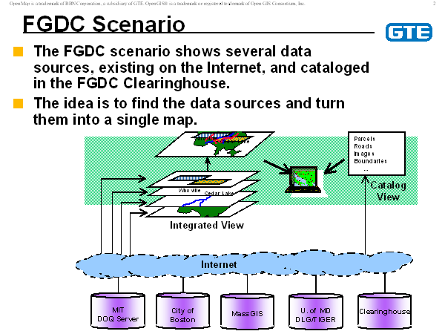
Anyone who is knowledgeable about cartography knows that, the last ten years, this trade has become highly dependent of information technology. GIS, which is for a large part based on cartographic concepts and principles, has become a multimillion dollar industry and pushed geographic thinking and awareness more to the centre of attention. One will find geographical technology in places nowadays where it was unknown ten years ago. The commercial world has discovered GIS as a valuable tool for spatial reasoning and planning. All this activity leads to an ever growing ocean of spatial data, that awaits processing or reprocessing. This situation lead to the development of the concept of data mining and data warehouses(Fig. 1). It boosted the development of standards for information interchange. The Federal Geographic Data Committee (FGDC) in the United States co-ordinates the development of the National Spatial Data Infrastructure (NSDI). The NSDI encompasses policies, standards, and procedures for organisations to co-operatively produce and share geographic data. The metadata standards, like the one of the FGDC, and interchange formats are the enabling technology for this widespread acceptance of geographic information technology. A an other interesting example is the Open GIS Consortium, a group of vendors in GIS technology together with users have set up specifications to let GIS-products interoperate more efficiently with each other. This lead to the emergence of new products that cross over the boundaries of the vendor's realms and that make the use of spatial data much more transparent and less technology driven. An example of such a product is INTERGRAPH's GeoMedia, a program that is able to integrate data sets of various well known GIS vendors.
Figuur 1 The US National Clearinhouse Concept (FGDC)
The situation described above is the premise for the modern atlas cartographer. In 1993, during the seminar on Electronic Atlases in Visegrad, Hungary a new definition of the atlas as a means to communicate geographical information was presented:
An atlas is a systematic and coherent collection of geographical data in analogue or digital form, representing a particular area and/or one or more geographical themes, together with tools for information retrieval, analysis and presentation. (Koop, 1993)
This workable definition tries to bridge the gap between the paper atlas and the atlas in an electronic format. It suggests a continuum between both types and that one does not preclude the other. In fact this definition focuses on content more than on technology. The geographical data take a central place in the picture. The fact that these data are well organised, pre-processed and put into well manageable chunks of information make an atlas stand out from a GIS or, if you like, a spatial data warehouse. Although the traditional paper atlas will keep its market share in the consumer and educational environment, the scientific users will gradually accept the atlas information system as the way to go. The reason for this is the fact that all data will be made available in digital form and access to these data through information technology is the most efficient and cost effective way. Nevertheless there will always be cross breeds, where the advantages of the data driven information system is combined with the arm chair qualities of the paper atlas. In the consumer market there are numerous product, that bare the qualification atlas and that are being published in digital form on a medium like CD ROM or DVD.
The remainder of this paper will deal with a project carried out at Utrecht University, concerning the improvement of map content in a consumer atlas. Furthermore some attention will be paid to the current state of the art in development tools that may push the electronic atlas, or the atlas information system, further ahead.

Electronic Atlases in the Commercial World

Current situation
In this paper "the commercial" world' will be limited to those companies that cater the consumer market. For the professional or scientific market the available products are limited. In section 3 the option for this market segment with respect to product development will be treated.

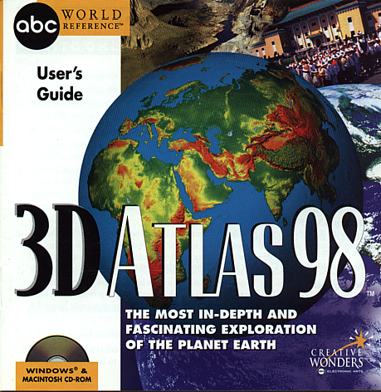
The last 5 years the market in personal computing has exploded. Substantial numbers of people are owning a personal computer of some kind. The introduction of easy to use self installing, plug-and-play operating systems have boosted the penetration of this technology in society. The personal computer has become the VCR of the 1990's. Most people would like to have one and many of them consider it a recreational device. A common motive to purchase a computer in a household are the educational qualities of the machine. As with a VCR a computer needs software in order to enable it to show its magic tricks. Since most people buy the machine as an educational tools, educational software titles are first on the wish list. Vendors of computers recognise this and bundle popular titles with the PCs for a bargain price. Electronic atlases on CD ROM belong to the most popular category of these educational software titles. A quick review of the market in 1998 shows a wide range of atlases available. Publishers like Comptons, Dorling-Kindersley, Electronic Arts and Microsoft are among the leading competitors. Competition causes a rapid increase in features, but not necessarily product quality. Vendors use for example the number of geographical names included on their CD ROM. Rand-McNally claims to have 1.7 million names and Microsoft 1.3 million in their atlas products. These sheer numbers do not make sense from an editorial point of view. One may try to find a name by searching the database, but only a relatively small number of names actually make it to the maps automatically.
Figure 2 3D Atlas Cover
In the upcoming years a growing number of these kind of atlases will emerge on the market. An interesting phenomenon in the CD ROM publishing of reference material is the rapid turnover of editions. Microsoft for instance aims at releasing a new version every year. This frequency was unheard of in the days of analogue publishing, where only the very large companies could afford a five year cycle. It poses questions though if the market will be able to absorb this stream of products on the long run. The commercial approach governs the short life cycles of these product under the following conditions:

- consumer products are highly competitive
- cost recovery is vital to survival of product
- tight budgets rule production
- yearly updates constrain the editorial process
- quality monitoring is long term process

The Microsoft Encarta World Atlas
The Microsoft Corporation needs no introduction. Most of us computer users use the Windows Operating system and are writing on MS Word. The profile this company has developed over the last 25 years is remarkable judging from its countless number of products and its dominance in ICT market and, not in the last place, the reputation of its chief executive officer. In this setting Microsoft has set up a range of reference titles for the home computer user among which the Encarta-series takes the most prominent and prestigious place. Encarta consists of the Encarta Encyclopedia as the flagship product. Next to the encyclopedia the World Atlas or, in the US, the Virtual Globe en the Bookshelf accompany the encyclopedia. In The United States these three products are currently (1999) being marketed as an integrated collection on the new DVD medium, the successor to CD ROM, as the Encarta Reference Suite 99.

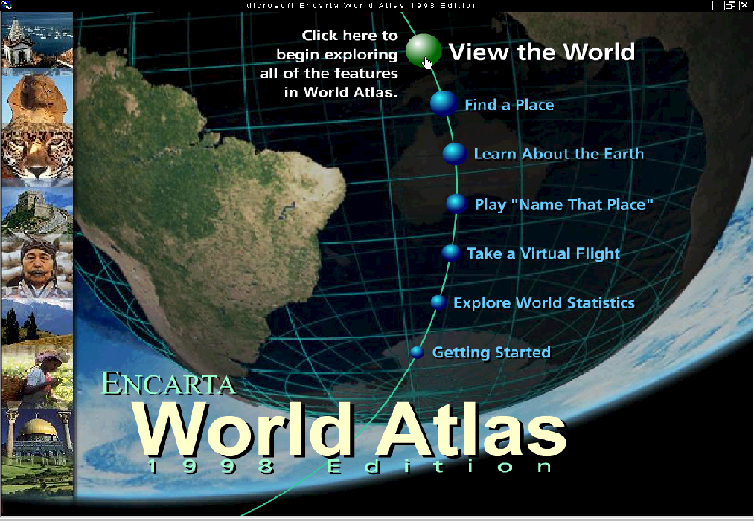
In this paper we will take a closer look at the development of the Encarta World Atlas (EWA). The EWA is a world reference atlas on CD ROM for the average home user, not necessarily for the educational market. It contains comprehensive topographical information covering the whole world at a scale approximating 1:250.000 to 1:1.000.000. Next to the mapping, the atlas contains comprehensive editorial content, that meets the standards set by big brother the Encarta Encyclopedia (EE). With comprehensive we mean that both mapping and content articles are supplying more information than the competition as mentioned above. The quality of the mapping is fair at first glance and the accuracy and thoroughness of the content articles has proven to be good, even excellent. This judgement is based on a thorough review of the product by the author of this paper. The mapping of EWA is presented to the user in the shape of a on-screen globe (virtual globe). The mouse pointer changes in a hand with which one may turn the globe in any direction. Actually the globe is a real time interactive animation of a orthographic map projection. By zooming in the user may reveal more detail and home in on a desired area. The atlas contains various tools to aid the user. Finding a toponym by entering it into a search dialogue leads to a list of similar toponyms with a brief local indicator of where the various alternatives are located. The content consists of articles about countries and numerous geographical themes, among which quite accurate articles about cartography, remote sensing, GIS, geography and map-reading. EWA contains multimedia content, like short full-motion video clips, photographs, animations, sounds and music, virtual reality flights, statistical data with thematic mapping and all these things may be updated by direct WWW-links, accessible through the user interface.
Figure 3 Opening screen EWA

We already mentioned that the quality of the mapping is fair. When mentioning quality one should realise that in this paper the term quality will be limited to map labeling, which is the most prominent feature of this kind of mapping. When browsing EWA one will probably discover many errors in the labeling. Partly these errors are due to flaws in the labeling engine in the software, but many are erroneously recorded in the names database. To properly understand the way the mapping came about, a short look at the About-information of the product will show that the following organisation supplied in one way of the other the source material.
- SPOTView satellite imagery
- United States Board on Geographic Names, Advisory Committee on Antarctic Names
- United States Defense Mapping Agency
- United States Department of Commerce, National Oceanic and Atmospheric Administration, National Environmental Satellite, Data, and Information Service, National Geophysical Data Center
- United States Geological Survey, National Mapping Division
- Eros Data Center
- Smithsonian Institution
- Scripps Institute of Oceanography
- World Data Center
- Gridded Population of the World database
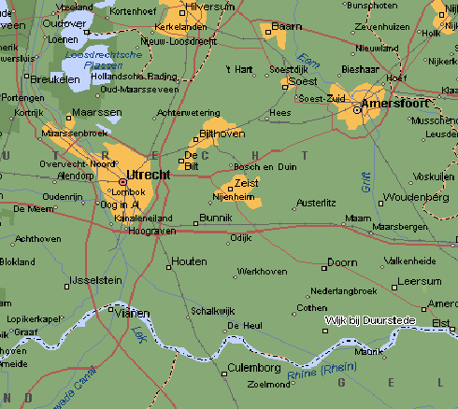
Figure 4 Largest available scale level in EWA
Most of these sources supply the data free of charge and therefor free of responsibility. For some areas outside North America Microsoft acquired data from commercial vendors, like AND in the Netherlands. The chosen approach to work with public domain material is at the same time a weak spot. Errors in the source material will shine through in the end product, unless scrutiny is put upon the collective database. Pubic domain sources contain errors, because the priorities of the mapping agencies differ completely from an atlas producer and the material is usually out of date. To tackle this problem the Microsoft Geo Unit devised a scheme to proof the mapping, the Map Bash Project.

Improving the Quality of Content: The Map Bash Project
The University Map Bash Program Pilot Project was set up by David Lanter and Howard Vergin of Microsoft. It was set up to deal with the enormous task to get rid of all the errors in the mapping/labelling database. The idea was to create a synergy between universities teaching geography and the EWA-team. It would allow the universities to use EWA in teaching in sufficient numbers of copies and it would bring back error reports to improve the map content.

Quality control is a very important feature of any publisher especially for Microsoft, since this company has a very high reputation in the computer market. To get a better grip on things most publishers set a number of quality criteria and tap a number of sources to get feedback from the editors of the market. The list below illustrates in decreasing importance the quality assurance process with these type of high profile products:

Superficial quality of the product
- Is it slick enough?
- Is the box cover appealing?
- Are marketing people satisfied?

Content Quality
- Are the Editors satisfied?
- Are the Advisers satisfied?
- How does the Public react (feedback reports etc.)?

Mapping Quality
- Is the Geomodeling Quality Assurance Team satisfied?
- Are the Advisers satisfied?
- What did the Map Bashers find?
- How does the Public react (feedback reports etc.)?

The Map Bashing may be a useful tool, but has in the whole process of publishing a rather limited role. Nevertheless it is an interesting concept to a university and enables student in cartography to look at such a product in a much more systematical way. Whether this approach is really useful to geography students is doubtful.

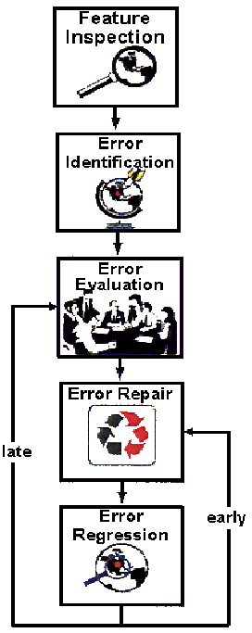
In Utrecht a group of ten students took up the challenge to participate in the experiment. The idea behind Map Bash is the bottom-up proofing of the product by means of a top-down co-ordinated effort by Microsoft. To achieve this a number of proofing manuals were supplied and the necessary CR ROM's of a beta-release of Virtual Globe 98 were issued. This release differed from the final release among many other things in the fact that in contained the so called Feedback Wizard. A software module with which the Basher could point to an error in the map and enter the required comments about the error. Every error would result in a file, and all files where routed to Microsoft through the email.
Figure 5 The proofing process

The Map Bashers had some clues from the documentation to what type of errors to look for:

- Map completeness
Feature omission and commission
- Label Completeness
Label omission and commission
- Feature damage
location, shape, symbology & typology
- Label Content
- Fictious features

The proofing process as shown in figure 5 was limited to context proofing, wher a region was scrutinised to the limit. Each participant was given an assignment where a specific region of the Netherlands had to be reviewed in al its aspects. The alternative approach, called feature proofing was not done. Feature proofing is a technique where a proofer only looks at one specific feature type, i.e. rivers town, boundaries etc. All assignments where finished within 10 to 12 hours. This exercise resulted in approximately 300 error reports

In Figure 6 and 7 some examples of the errors taken from the documentation are illustrated.

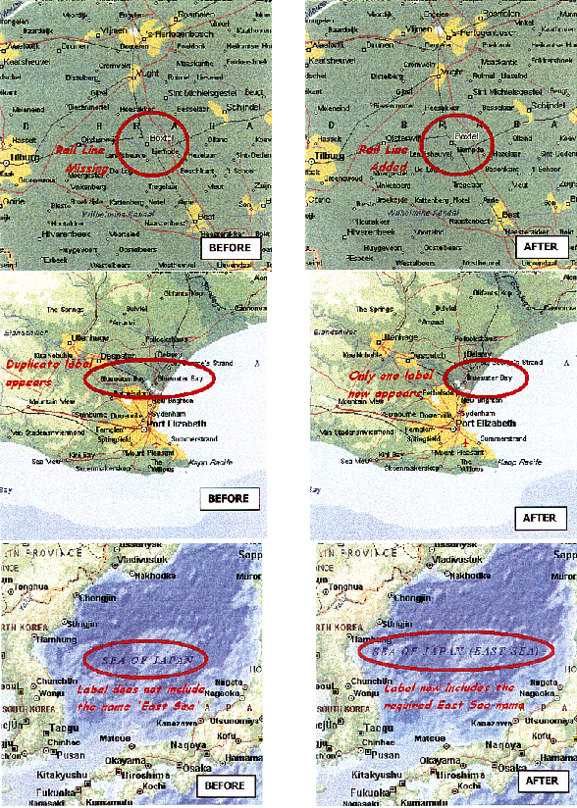
Figure 6 Tree examples of errors in the EWA labelling

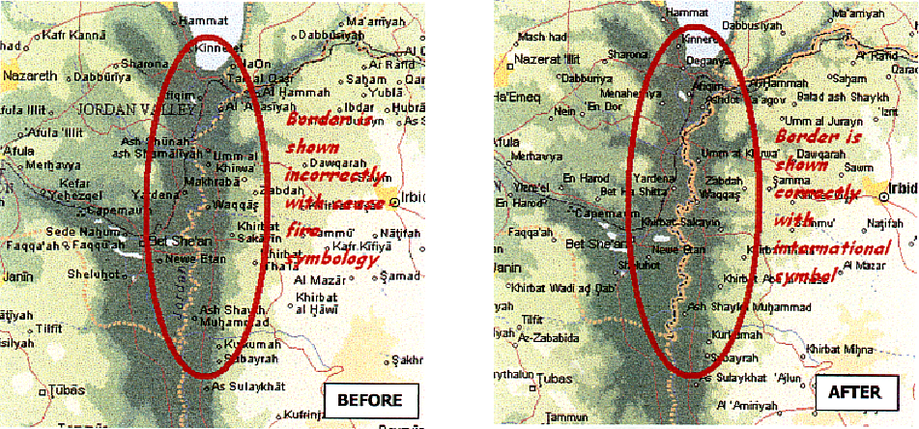
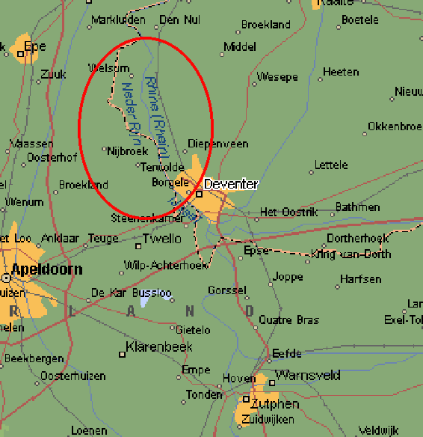
Figure 8 shows a typical error due to a combination of database and labelling engine errors. In this particular case the river IJssel in the Netherlands gets names from other branches of the river Rhine.
Figuur 7 Errors in map symbology
Figure 8 Labeling is a mess!

Figure 9 The urban blobs are out of date
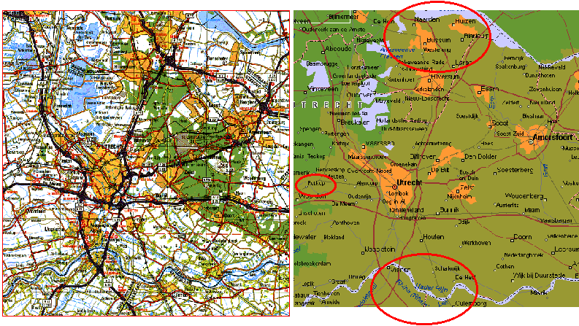
Figuur 9 The urban blobs are out of date
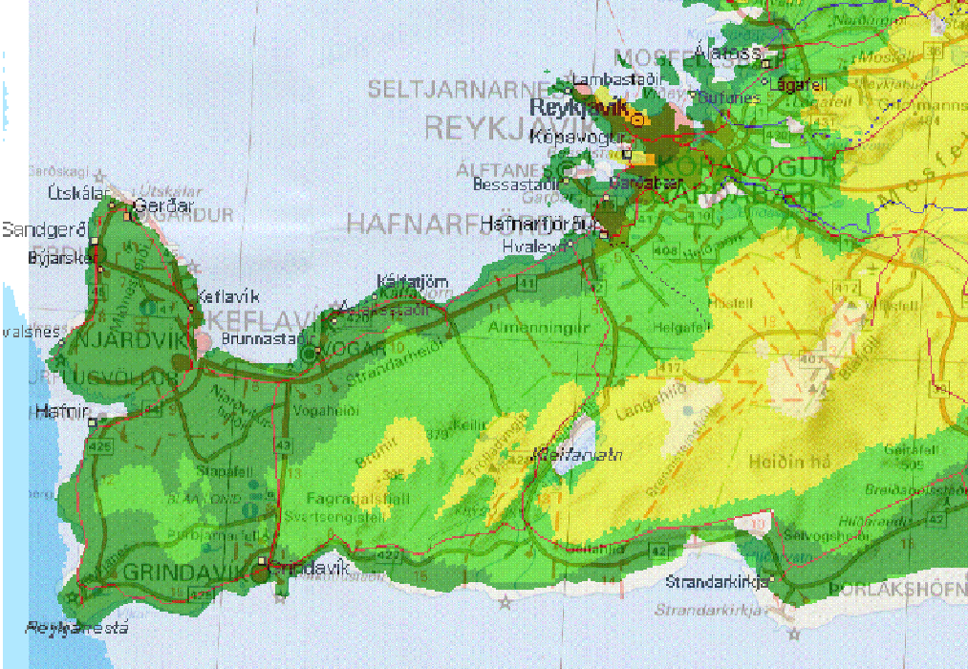
The yellow/light area's in the mapping signifying the built-up or urban area's are out of date (Figure 9). For comparison a copy of a paper map was added. The lower ellipse indicates another labelling chaos along the river and smaller ellipse on the left is a name that does not make any sense. It does exist but is of no importance. Actually it is just a road house and a few house next to a railway crossing and should be omitted. Other places of much higher importance are missing from this map view (but are searchable though).
Figuur 00 EWA map superimposed on a papermap of Iceland

The last example (Figure 10) of this series is a fragment from Iceland (Reykjaness-peninsula). In this example the mapping from EWA was superimposed on the official 1:500.000 map of Iceland, by geometrical referencing with Mapinfo Professional and making it transparent with Adobe Photoshop. The thin lines stem from EWA as does the poor type. It gives some indication as for the quality of the geometry of EWA, which is in this case much poorer than the paper map. One should realise that the quality of mapping differs throughout the product due to differences in source material.

Although the Map Bash Pilot was a one off as far as Utrecht University was concerned it is an interesting concept. When it is not part of the curriculum students might be reluctant to participate and need another incentive. Adopting a part of the map and a free copy of the final product might be very tempting to many. From a atlas editorial view, the Map Bash concept may cause a severe variance in quality throughout the product, which is in principal bad editorial practice. It might help speed up the evolution of the product though, taking the drawbacks into account.

Tools for Developing an Atlas Information System

Visegrad, 1993!
During this very interesting and stimulating seminar in Visegrad in 1993 of three ICA commissions, prior to the ICC in Cologne, Germany the first presentation about tools for developing electronic atlases was presented. This presentation also introduced the content oriented definition of the atlas as an information product. Since then technology has come a long way. Not only have computers evolved, but the whole software industry has changed, due to e revolution in information technology: the INTERNET and communication technology. Building electronic atlases for professional purposes, is nowadays a primarily aimed at co-ordination and integration of a wide variety of on-line data sources. In 1990 (Koop and Ormeling, 1990) suggested that there may be three ways to go in setting up an electronic National Atlas. In both three models there was a role foreseen for communication technology:

- The Clearinghouse Model, aimed at replicating data in a central repository and guided by an editorial staff.
- The Broker Model, aimed at the processing of requests or transaction through a central switchboard, but without actual data replication
- The Coordinator Model, aimed at just creating guidelines for direct communication between data supplier and user.

Nine years later, at the turn of this century, all models had their chance to evolve and it turned out to be the Coordinator Model to be the most successful (and the less favoured by the original authors). From a editorial point of view, stemming from the traditional atlas editing environment, atlas editors want to stay in complete control. Data replication is the only way to go if you want to achieve that. However, current technology does not really allow this to happen. Distributed data concepts are dictated by the INTERNET-technology and all the communication and information science aspects that come with it. The Coordinator Model is now called in reality a "clearinghouse", which is not a right term for this phenomenon. The National Clearinghouse of the FGDC is in fact just a concept to effectively exchange data between parties. Whatever name things get the atlas cartographer will have to find his or her place in this field.

The Network is the Computer
The title of this section is taken from a commercial by Sun Microsystems. It addresses the idea that single, stand-alone computers have ceased to exist and that all computers together, linked through wires, have become one big ICT organism. Perhaps this will become in some way reality in the future, but for now it is a very workable concept if we just limit it to the distributed data of an electronic atlas.

For an average user it is of no importance where date actually come from, as long as the information requirement is met. Navigation through data must be transparent and problem driven. To achieve this ICT alone is not enough. Sophisticated exchange concepts must be elaborated and probably the highest "life form" within this world is meta-information, that guides the user to its target.

The information and communication technology has given us the networking concepts to work with. Traditionally the client/server concept (Figure 11a) ruled the corporate world for many years. In this concept a network of smart PC's with a lot of local software installed interoperated with one or more central computers that hold the data centralised.

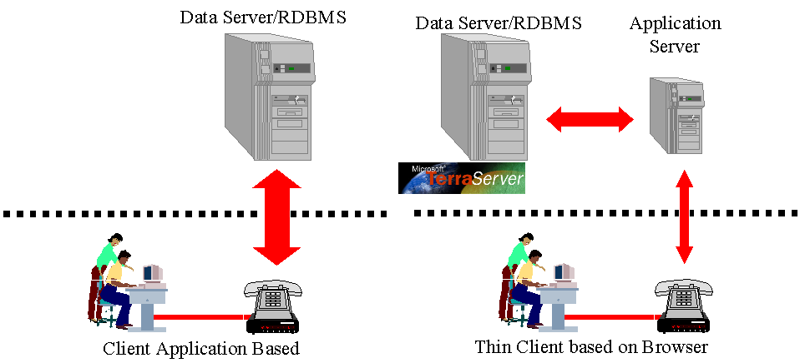
A new approach that came about with the evolution of INTERNET technology is the three-tier client/server architecture (Figure 11b). In this situation the user has only a, so called, thin client at his or her disposal. The thin client is a stripped computer that in its simplest form is based on a Java-enabled browser. All applications that are required for a specific task are being sent tot the thin client by the application server when needed. The application server also acts as mediator between the client and the data server. The thin client is in reality a browser like Netscape Navigator or Internet Explorer running on a PC or other desktop computer.
Figure 11a The Classic Client/Server Concept Figure 11b The Three Tier Client/Server Concept
An example which is related to the electronic atlas theme is the Terraserver from Microsoft (Figure 12)
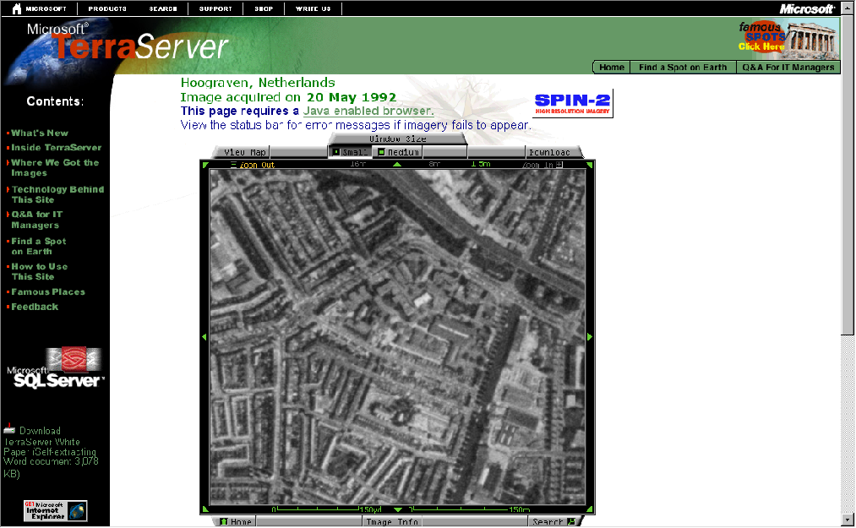
Figuur 12 The Microsoft Terraserver
The Terraserver holds an large amount of high resolution imagarey from space that the user may zoom into by means of an application that is run bij an application server. By clicking the button om top of the image the user may zoom out or pan. This application does not utilise local applications, better known as applets or ActiveX controls.

The commercial products discussed in the next section will use the applets and ActiveX controls.

New Commercial Tools
Building three tier client server applications with atlas or (if you like) GIS features has become a growth market for vendors of GIS technology. All vendors use basically the same technology based on the common INTERNET/INTRANET technology:
- Platform is less important
MacOS & Windows 98/NT
- Visual Basic and/or C++ developing environment
- ActiveX Controls
Windows bound
- HTML, Java, Shockwave (Internet)
- RDBMS with ODBC
- GIS Libraries of major vendors
- Data viewers
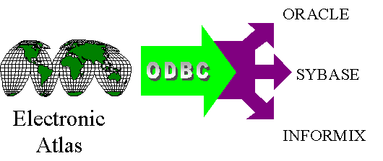
Figuur 13 The ODBC Concept
Because the browser is the core of the application it acts as a neutral interface between the network and the operating system. The browser accepts Java-applets and ActiveX controls that have a similar function, but are, for now, limited to Microsoft branded operating systems. ODBC (Open Data Base Connect) is a concept (Figure 13)where a user may access any relational database, that supports ODBC requests (most professional database systems), transparently, through the standard ODBC interface. With ODBC it is also possible to access different databases at the same time combining the both data sets in relational queries. ODBC's transparency is an important technology for those who would like to build electronic atlas information systems.

The main players in the commercial GIS world have put products on the market to develop three tier applications.

Environmental Systems Research Institute (ESRI)
ESRI has the largest market share in GIS products with its leading software package Arc/Info. To enable their client to put thin client application on the INTRANET or even on the INTERNET there are a number of products available. ESRI has two INTERNET Map Severs (IMS). The first is being put to work in combination with the popular Arc/View software. A user may actually access a running Arc/View application through the web browser. The IMS sends a number of ActiveX controls to the browser together with a map. Zooming in and out and activating functions in the browser of Arc/View are possible.

Another approach are the MapObjects (Figure 14). This is a library of functions available to the VisualBasic programmer with which a custom application may be produced. An example of a screen from such an application may be seen in Figure 15. The data are sent to the browser through the MapObjects INTERNET Map Server. Where The Arc/View IMS a very Arc/View like application yields, the MO/IMS will enable the developers to program a totally customised application. The problem with these map servers, that they are rather expensive to acquire in license. Experimenting is therefore difficult. ESRI licenses these products to universities in a campus licence though, so we should expect to see these applications coming from that source.
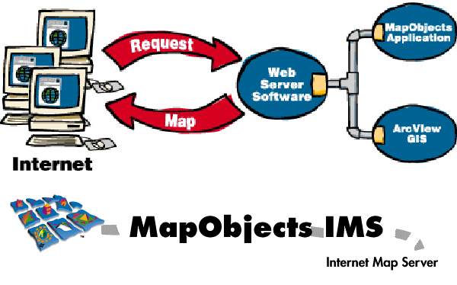
Figuur 14 ESRI's web solutions
MapObjects has the following specifications:
- 30 ActiveX Mapping and GIS Components
- Components are sent to client by web server
- All major GIS and visualisation functions available
- Wide variety of image formats
- Use of RDBMSes (ODBC & SQL)
- Integration via Visual Basic/C++ or Delphi

Mapinfo
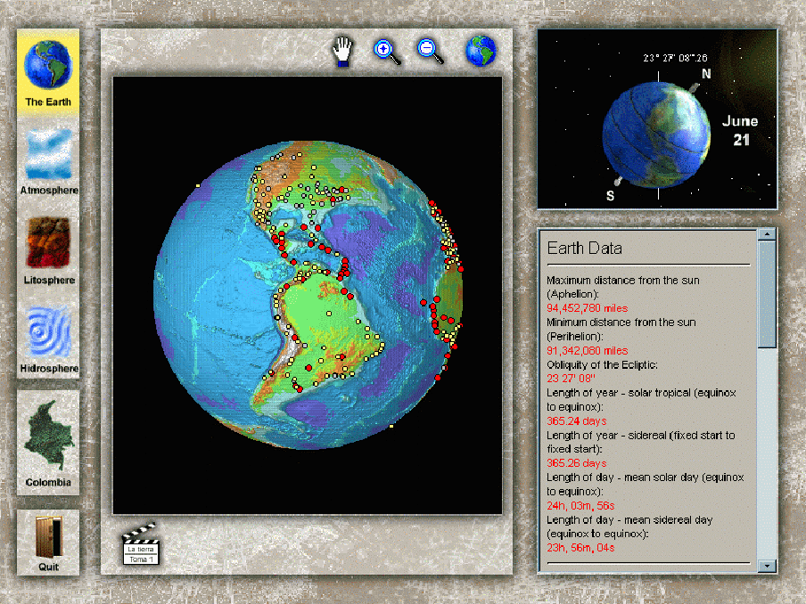
Mapinfo is traditionally one of the major players in the desktop mapping scene. Mapinfo may be put on the network with the MapBasic programming language in combination with the MapX ActiveX controls and through the MapXtreme application server. It is comparable with the Arc/View IMS.
Figure 15 Example of a possible MapObjects application

INTERGRAPH
This company has recently put the product GeoMedia in the market. This is a unique software concept based on the Open GIS ideas. With this software a user may integrate GIS data from various vendors together in one application. With the GeoMedia Web Map one may put this product into a web anabled environment

Autodesk
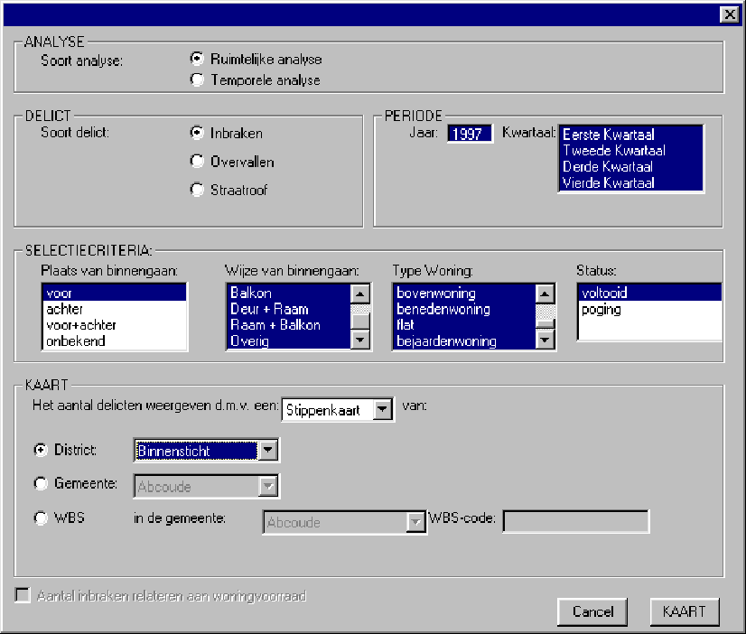
Autocad is the flagship of this company. The last few years Autodesk has moved into the GIS-mapping world. Recently the software product MapGuide enables users to build INTRANET/INTERNET applications in a user friendly fashion. It is aimed at the large scale mapping applications.
Figure 16 An example of a user driven atlas information system for crime analysis

To conclude we see that these development are moving ahead rapidly. The need for a co-operative effort like the proposed EUMEA initiative (Koop, 1996)has become less urgent. The tools, so desperately needed for the development of electronic atlases, are there, supplied to us by the commercial vendors. For now the MapObjects in combination with ODBC solutions seem to bee the most viable for electronic atlas production.

A Case Study from Utrecht
We have been discussing a lot the possibilities of network based publishing. This does not mean that other options are suddenly old-fashioned. Sometimes a limited number of retrieval sites are required, or the product is intended to be distributed off line. In Utrecht an ongoing co-operation is set up with the local Police, Detective Branch. Through two final projects of student the introduction of geographic information technology has become a fact in this organisation. The last project involved building a stand-alone geographical management information system, where the police chief and his staff may retrieve maps about the current and recent crime situation. In figure 16 the transaction panel is shown. Based on the required information the user can fill in the various fields. The user may choose the type of crime (burglary, robbery or street robbery), the way the crime was committed, the administrative subdivision and the year and quarter. Figure 17 shows a result map.

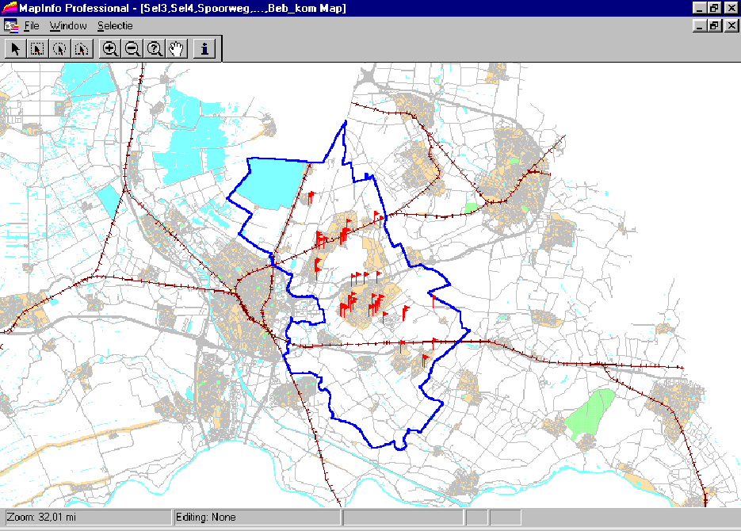
Figuur 17 Result of an analysis with the Crime Information System

Conclusions
This paper addressed two aspects of electronic atlas development. First of all we took a peek inside the commercial development of consumer atlases, followed by some remarks about the state of the art of atlas building and its relationship to the current developments in the ICT world, in particular the INTERNET-revolution. To finalise this paper the following concluding remarks are appropriate:

- No matter how sophisticated an electronic atlas concept has been elaborated, the quality of the actual content prevails in relation to the overall product specifications and its commercial success
- Up to date atlases are the only way to go in the information age
- a professional electronic atlas will highly depend on ICT
- three-tier client/server architecture with thin clients are the way to go
- GIS vendors will supply us with the necessary development tools
- Development of an electronic atlas remains an enormous task with a lot of co-operative effort and requires a sound financial foundation to be successful.

Finally, since this will probably my last contribution to the ICA Commission on National and Regional Atlases, because of my career move toward a regional government in the Netherlands, I would like to take this opportunity to thank everybody for all these wonderful and inspiring meetings I could attend in the wake Ferjan. So he is the first I would like to thank. Further my gratitude goes to Bengt, Tim and Eva whom I got to know as very knowledgeable colleagues and very good friends. Finally I would like to dedicate this paper to our good friend Gylfi who, very unfortunately, was not granted the time to attend this splendid seminar in his wonderful Iceland, the most beautiful country in Europe.

References
Mekenkamp, 1989, verhaal over zijn projecties

Koop, R.O., 1993, Tools for the Electronic Production of Atlases
In: Proceedings of the Meeting of the Commissions on National and Regional Atlasses, Education and Training and Map Use of the International Cartographic Association, Visegrad, Hungary, 27-29 april 1993.

Koop, R.O., 1996, Electronic Atlases in the European Domain. The Necessity to Standardise Development Tools for the Production of Electronic Atlases (Abstract).
Abtsract Book 28th International Geographical Congres, The Hague, 1996. Utrecht: Stichting Internationaal Geografisch Congres 1996. pp229-230

Ormeling, F.J. en R.O. Koop, 1990, The Transition of a Paper National Atlas to a National Atlas Information System
In: Proceedings ICA National Atlases Commission Meeting, Beijing, 8-12 Augustus 1990, p.p. 82-90

Open GIS Consortium on the WWW: http://www.opengis.org/
Compare the Comprehensive Times Atlas of the World, which has about 300.000 names in its register
DVD: Digital Versatile Disk, the successor to CD ROM, capable of holding up to 17Gb of data
Honesty demands to say that Olev Koop is a member of the board of advisers to the Microsoft Corp. in relation to the Encarta World Atlas; he has tried not to let this fact get in the way of objectivity

